Pilot Test of Zebrafish Anxiety

**Aim:** To determine differences in repeatability between novel tanks (those with greater depth) and traditionally used trapezoidal holding tanks in zebrafish anxiety experiments

**Background**

A common method used to measure Zebrafish anxiety is the novel tank diving test. Individuals are pre-treated and placed in open tanks for behavioural phenotyping. This method exploits the Zebrafish’s natural tendency to seek shelter in unfamiliar environments by diving, freezing, and reducing exploration. As such, researchers can model and assess anxiety by collecting data on behavioural parameters such as time spent at the bottom, latency to enter the upper half of the tank, total distance travelled, and freezing (Egan *et al.*, 2009).

While these tests are heavily employed, there is little to no research on using tanks that differ in depth to typical holding tanks. This is interesting as Zebrafish have been shown to prefer greater surface depth (Blaser and Goldsteinholm, 2012). As such, we believe utilizing tanks with increased depth will result in more variation in behavioural responses. This in turn will result in more reliable estimates of repeatability. Repeatability is an important index used to quantify measurement accuracy and the constancy of phenotypes. It is the proportion of phenotypic variation that can be attributed to between-subject (or between-group) variation (Nakagawa and Schielzeth, 2010).

**Materials and Methods:**

*Tanks*

We employed the use of two different tanks (see Figure 1): 1 non-novel holding tank (trapezoidal; at top widest point width 11cm, height 17.5cm, length at top widest point 28cm) and 1 novel tall tank (width 7cm, height 152cm, length 10.5cm). Each had a standardized mark displaying the water level at 3.4L (at xcm for the short tank; at 46.3cm for the tall tank).

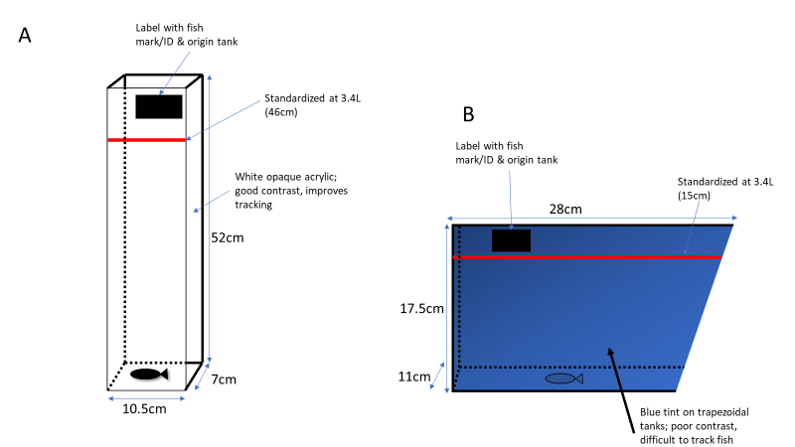

Figure 1) Tanks used in our anxiety experiments; A) Tall novel tank and B) traditional trapezoidal holding tank

*Animals*

We used a total of 160 WT zebrafish (n=80 males, n=80 females). Zebrafish were housed in 3.5L tanks (max 24 fish per 3.5-litre tank). We used a total of 8 tanks, with 20 fish in each tank (split evenly by sex) selected to be main experimental subjects. Remaining fish were used as spares to replace main fish in extenuating circumstances (i.e. death).

*Arena setup (tall tanks)*

When utilizing our tall tanks, we set up 6 tanks to run 6 fish per trial. All 6 tanks were set up side by side and facing the camera (See Figure 2). There must be space behind the tanks for the holding tanks. Once set up, their positioning will be marked with a whiteboard marker so as to ensure high accuracy of re-positioning once they are to be moved for changing of water. Tanks will be labeled appropriately with individual fish mark, and tank ID. Corflute is used to block all sides of the arenas except the front portion where the camera will be placed; this ensures that fish are not disturbed during trials. Tape is used to secure the corflute, with the back portion being removable for treatments to be administered to the fish before placing them in the tank.

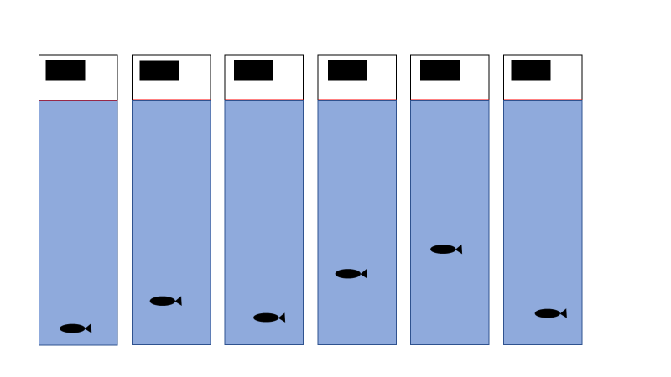

Figure 2) Setup for tall tanks

*Arena setup (trapezoidal tanks)*

When utilizing our trapezoidal tanks, we set up 8 tanks to run 8 fish per trial. Unlike the tall tanks, the setup required for the trapezoidal tanks required the use of 2 cameras (4 tanks per camera). In order to fit 4 tanks in the frame of one camera, we used a platform (raised approximately 25cm) to place two tanks on top (corflute was placed in between the tanks on the raised platform to block each tanks view of other tank). The other two tanks were placed on the original platform beneath and slightly closer to the camera (corflute was also placed between the tanks). This would result in an even image in terms of tank positions (see Figure 3). To be able to use 8 tanks, this same setup was used on the other half of the main platform (corflute was placed between both setups). Once set up, their positioning will be marked with a whiteboard marker so as to ensure high accuracy of re-positioning once they are to be moved for changing of water. Tanks will be labeled appropriately with individual fish mark, and tank ID. Since two sides of the platform was used, corflute was only placed on the sides where the camera wasn’t placed. Holding tanks for zebrafish were prepared away from main platform.

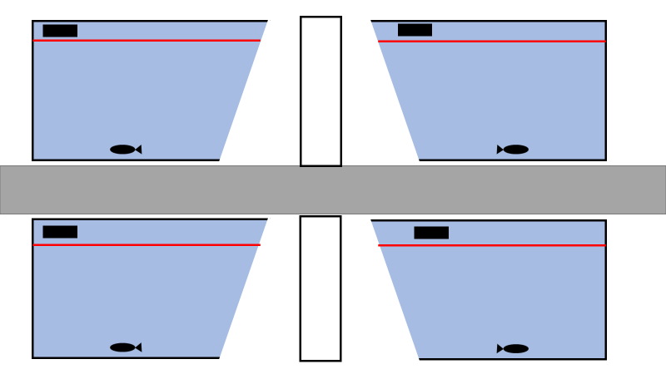

Figure 3) Setup of 4 trapezoidal tanks per camera

*Camera setup*

A camera will be attached to a tripod and placed 1 meter from the arena set up to ensure they are all captured. Recording will be controlled remotely by a wireless tablet connected to a HD Panasonic video camera via Wi-Fi. Care must be taken to ensure the positioning of the camera so that all tanks are in clear view and the entirety of the tank can be seen so there are no blind spots when recording. Ensure all lights are on and that the setup is clear and not dim (look at the camera and ensure tanks do not look yellow or dark with shadows). Further it is important that the camera not move, as this will make Ethovision work difficult.

NOTE: To make the trial higher throughput for tall tanks, one can employ the use of two cameras to film 8 tall tanks as opposed to 6 (4 per camera).

*Zebrafish setup tall tanks*

Zebrafish required for the experiment will be extracted from their tanks with a net and placed into individual holding tanks. There will be a total of 12 individual holding tanks when using tall tanks. These are small tanks fitted with a plastic strainer in the same form of the tank so as to remove the fish without using a net (See Figure 4). They are 14cmx9cmx9cm and approximately have a capacity of 1.13L. They will also be marked to ensure the fish are placed in the correct tank. 6 holding tanks will be placed behind the tall tanks on the main platform. These will have fish that are prepared to run the trial. Once fish are placed in the tall tanks for the trial, these tanks will stay on the platform. The next set of fish to be used will be placed in another 6 holding tanks that are set up away from the main platform. These will then be swapped with the empty tanks that are behind the tall tanks on the platform. Process will repeat.

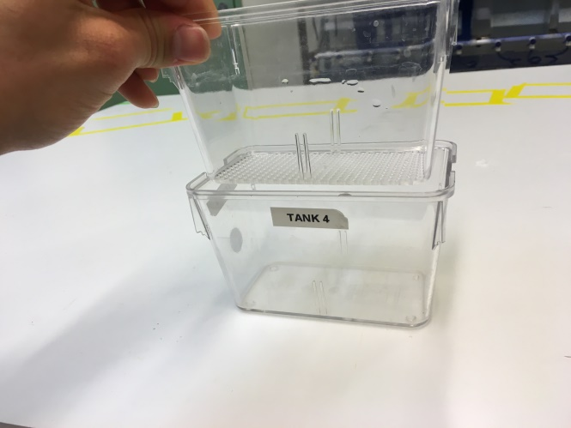

Figure 4

*Zebrafish setup trapezoidal tanks*

As there is no space to leave holding tanks on the main platform, preparation must be done away from the platform. Only 8 holding tanks are required for when zebrafish are run using trapezoidal tanks. Once zebrafish are placed into their respective holding tanks, they are ready to be transferred into experimental trapezoidal tanks.

*Experimental design*

Each individual will experience the anxiety assay in each tank twice. For each experiment, all fish were run in a single day. Order of tanks run were pseudorandomized to account for day of experiments as well as time of day. Individuals were then selected randomly to run in trials. Final experimental design was as follows (numbers indicate tank):

|  |  |  |  |  |
| --- | --- | --- | --- | --- |
| **TOD** | **Day 1** | **Day 2** | **Day 3** | **Day 4** |
| **Morning** | 1 | 8 | 5 | 4 |
| **Morning** | 2 | 7 | 6 | 3 |
| **Noon** | 3 | 6 | 7 | 2 |
| **Noon** | 4 | 5 | 8 | 1 |
| **Noon** | 5 | 4 | 1 | 8 |
| **Afternoon** | 6 | 3 | 2 | 7 |
| **Afternoon** | 7 | 2 | 3 | 6 |
| **Afternoon** | 8 | 1 | 4 | 5 |
| *Dates* | 2/03/2020 | 4/03/2020 | 6/03/2020 | 9/03/2020 |
|  | Mon | Wed | Fri | Mon |
|  |  |  |  |  |
| ***Tank types:*** |  |  |  |  |
|  | Old_Wide |  |  |  |
|  | New_Tall |  |  |  |

*Experimental procedure*

Fish will be recorded for a total time of 8 minutes (a single trial). Acquisition of data will begin after 40 seconds as this will allow camera to settle with contrast. The testing area should be devoid of sudden and rapid movements, noise or vibrations during trials. Care must also be taken to ensure nothing gets in the way of the camera. Record any events that may affect the outcome of the trial or experimental settings during data acquisition. Commonly encountered events include fish jumping from the net upon entry into experimental tanks, the camera or tank being moved, or there are incorrect/misplaced labels.

While an active trial is on-going, prepare the next batch of fish individuals from their group tanks to their pre-trial holding tanks. Also prepare their corresponding labels taking note of fish marking and individual/group ID.

After recording, carefully remove fish from the test tank using hand nets, returning them to their group tank or a temporary container (so as not to mix tested and untested individuals). Remove old labels from the experimental tanks and add new labels. Continue forth with the remainder of the trials.

After five trials, the water must be changed to ensure the next batch of five trials receive the same water temperature. Change water accordingly and make sure to place tanks back in line with the markings of their earlier positions. Take great care in ensuring the camera is not touched.

**References**

Blaser, R. E. and Goldsteinholm, K. (2012) ‘Depth preference in zebrafish, Danio rerio: control by surface and substrate cues’, *Animal Behaviour*. Elsevier, 83(4), pp. 953–959.

Egan, R. J. *et al.* (2009) ‘Understanding behavioral and physiological phenotypes of stress and anxiety in zebrafish’, *Behavioural Brain Research*. Elsevier, 205(1), pp. 38–44. doi: https://doi.org/10.1016/j.bbr.2009.06.022.

Nakagawa, S. and Schielzeth, H. (2010) ‘Repeatability for Gaussian and non-Gaussian data: a practical guide for biologists’, *Biological Reviews*. John Wiley & Sons, Ltd, 85(4), p. no-no. doi: 10.1111/j.1469-185X.2010.00141.x.